# **Functionality: Author Graph**

**User Story:** As a user, I want to see the relation between authors, so I can more easily know which authors worked together.

This functionality allows users to easily see which authors wrote an article in collaboration with other authors from the articles present in the library. **(JR3)**.

**Use case diagram 3:**

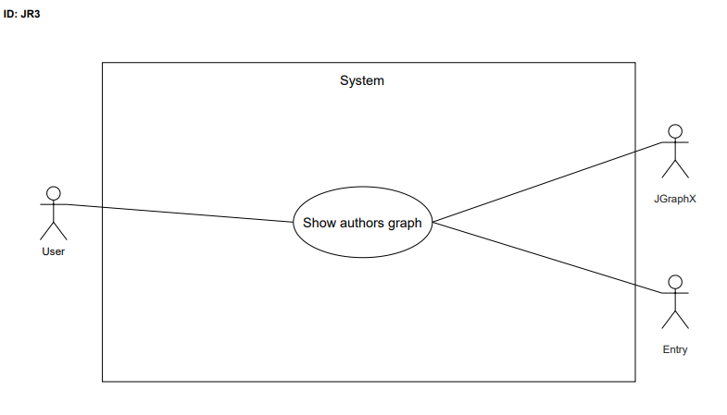

* Name: Show authors graph
* ID: JR3
* Description: Creates a graph with the relations between authors.
* Actors:
* Primary: User
* Secondary: JGraphX, Entry